# WCAG2.0_LevelA_CUI

|  |  |  |
| --- | --- | --- |
| Version | Dev | Notes |
| 1.0 | Harvey/Harry/John |  |
|  |  |  |

## CUI to Meet WCAG2.0 Level EPIC

<https://jirafnd.dev.activenetwork.com/browse/ANE-47843>

## Related Guidelines

### WCAG

<https://www.w3.org/TR/WCAG20/>

### ARIA

<https://www.w3.org/TR/wai-aria/>

### WCAG check Tool

1. <http://wave.webaim.org/>
2. Chrome extension

<https://chrome.google.com/webstore/detail/wave-evaluation-tool/jbbplnpkjmmeebjpijfedlgcdilocofh>

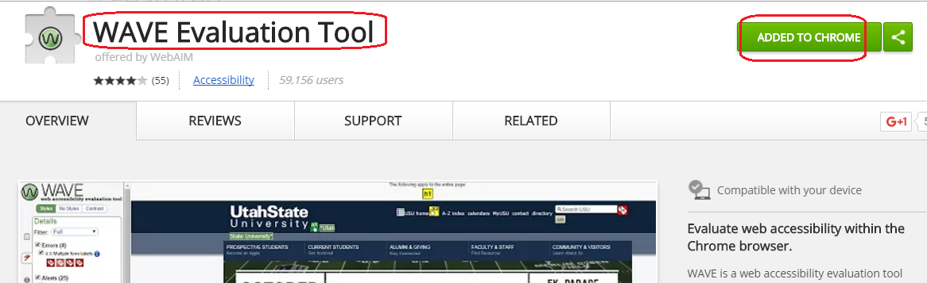

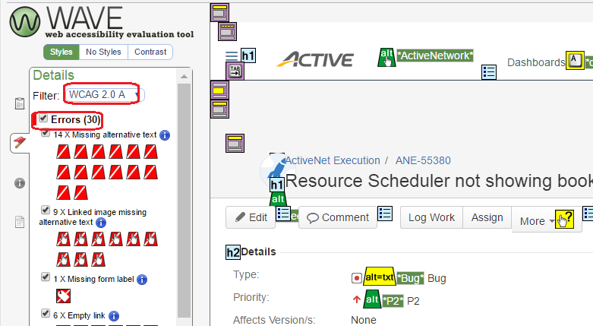

Dev must to fix the errors in current page.

### Screen Reader

<http://www.nvaccess.org/>

<http://usabilitygeek.com/10-free-screen-reader-blind-visually-impaired-users/>

## Special Case for CUI

<https://www.w3.org/TR/WCAG20/>

We also meet some special cases when does WCAG EPIC for ANet CUI, and summarize solutions:

### <table>

<https://www.w3.org/WAI/tutorials/tables/>

1. If use <table> as layout, please don’t use <th>, ‘summary’, and <caption>
2. If use <table> as data grid to show, please:

* Add <caption>, or ‘summary’

Just text is allowed to put in to <caption>, otherwise, if you put <input> or <a> in <caption>, ‘Tab’ and screen reader will can’t work well

* <th> is needed for data table, and column’s name is not allowed as null/empty

For columns display checkbox, display 'Select' as column header.

For columns display 'Add/Edit/Delete' links, display 'Action' as column header.

For columns display 'View' link, display 'View' as column header.

### <label> for <input> / <select>

1. Three ways to meet this rule, just need to pick up one way, doesn’t to full all:

<label for=”first_name”>First Name:</label>

<input=”text” id=”first_name” aria-labelledby=”label_id”>

<input=”text” aria-label=”enter first name”>

1. For one special case, <input> or <select> doesn’t have label, but “aria-label” is needed to meet WCAG:

Please don’t use:

<label for=”input_id” style="display:none>first name</label>

                                As screen reader also can’t read the “dsplay:none” info.

                Please to use [below one](http://blog.csdn.net/heye13/article/details/51720600), I have added this public css in “AN.css” file:

                                <label for="h_calling_code" class="hidelabel">calling code</label>

/*WCAG2.0 add hide labedl for some inptut, we need screen reader read out these info, but doesn't show for in browser*/

label.hidelabel {

                position: absolute;

                top: -30000px;

                left: -30000px;

### Tab focus

Tab can move focus to <a>, <input>, <select>, then screen reader will read label and their useful info.

For all of other info, screen reader just read from top to bottom of page.

### Link <a> with custom Event

If using <a> link as button, please add href=”javascript:void(0);”, then it can be focused by ‘Tab’, then screen reader can read the link.

<a href=”javascript:void(0);” onclick=”alert(‘alert’)”>Alert</a>

### <a> link without text content

If the content of the link is none-text (img, input) need to add aria-label for Link purpose

<a href=”google.com” aria-label=”google”><img src=””></a>

### Popup window

Need to satisfy visit the website only with keyboard, when the popup window open, the focus will always in the popup window, after using keyboard close the window, the focus will back to previous focus before the popup window open

### Clickable element

If the element can be click and trigger event by mouse, then the element should have the ability to be focus by Tab key and trigger by press enter key. Sometimes, need to add tabindex=1 to the element.

<img tabindex=1 onclick=”alert(‘alert’)”/>

### Remove the default focus

Remove the default focus after page loaded, otherwise it will interrupt the screen reader auto read the whole page

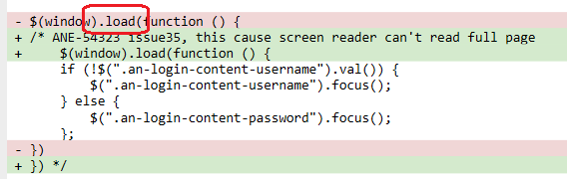

Remove JavaScript function ‘tabFirstField’ that will focus on one field after page load.

### Some controls do not need to be read

If some controls do not need to be read by screen reader, we can use the following way:

a. <div  aria-hidden=”true” role=”presentation”>

b. <div  class=”hidelabel”>

## Dev work flow

### Use WAVE to check your page hasn’t WCAG error

### If there is any WCAG error, please fellow #3 rules to fix them